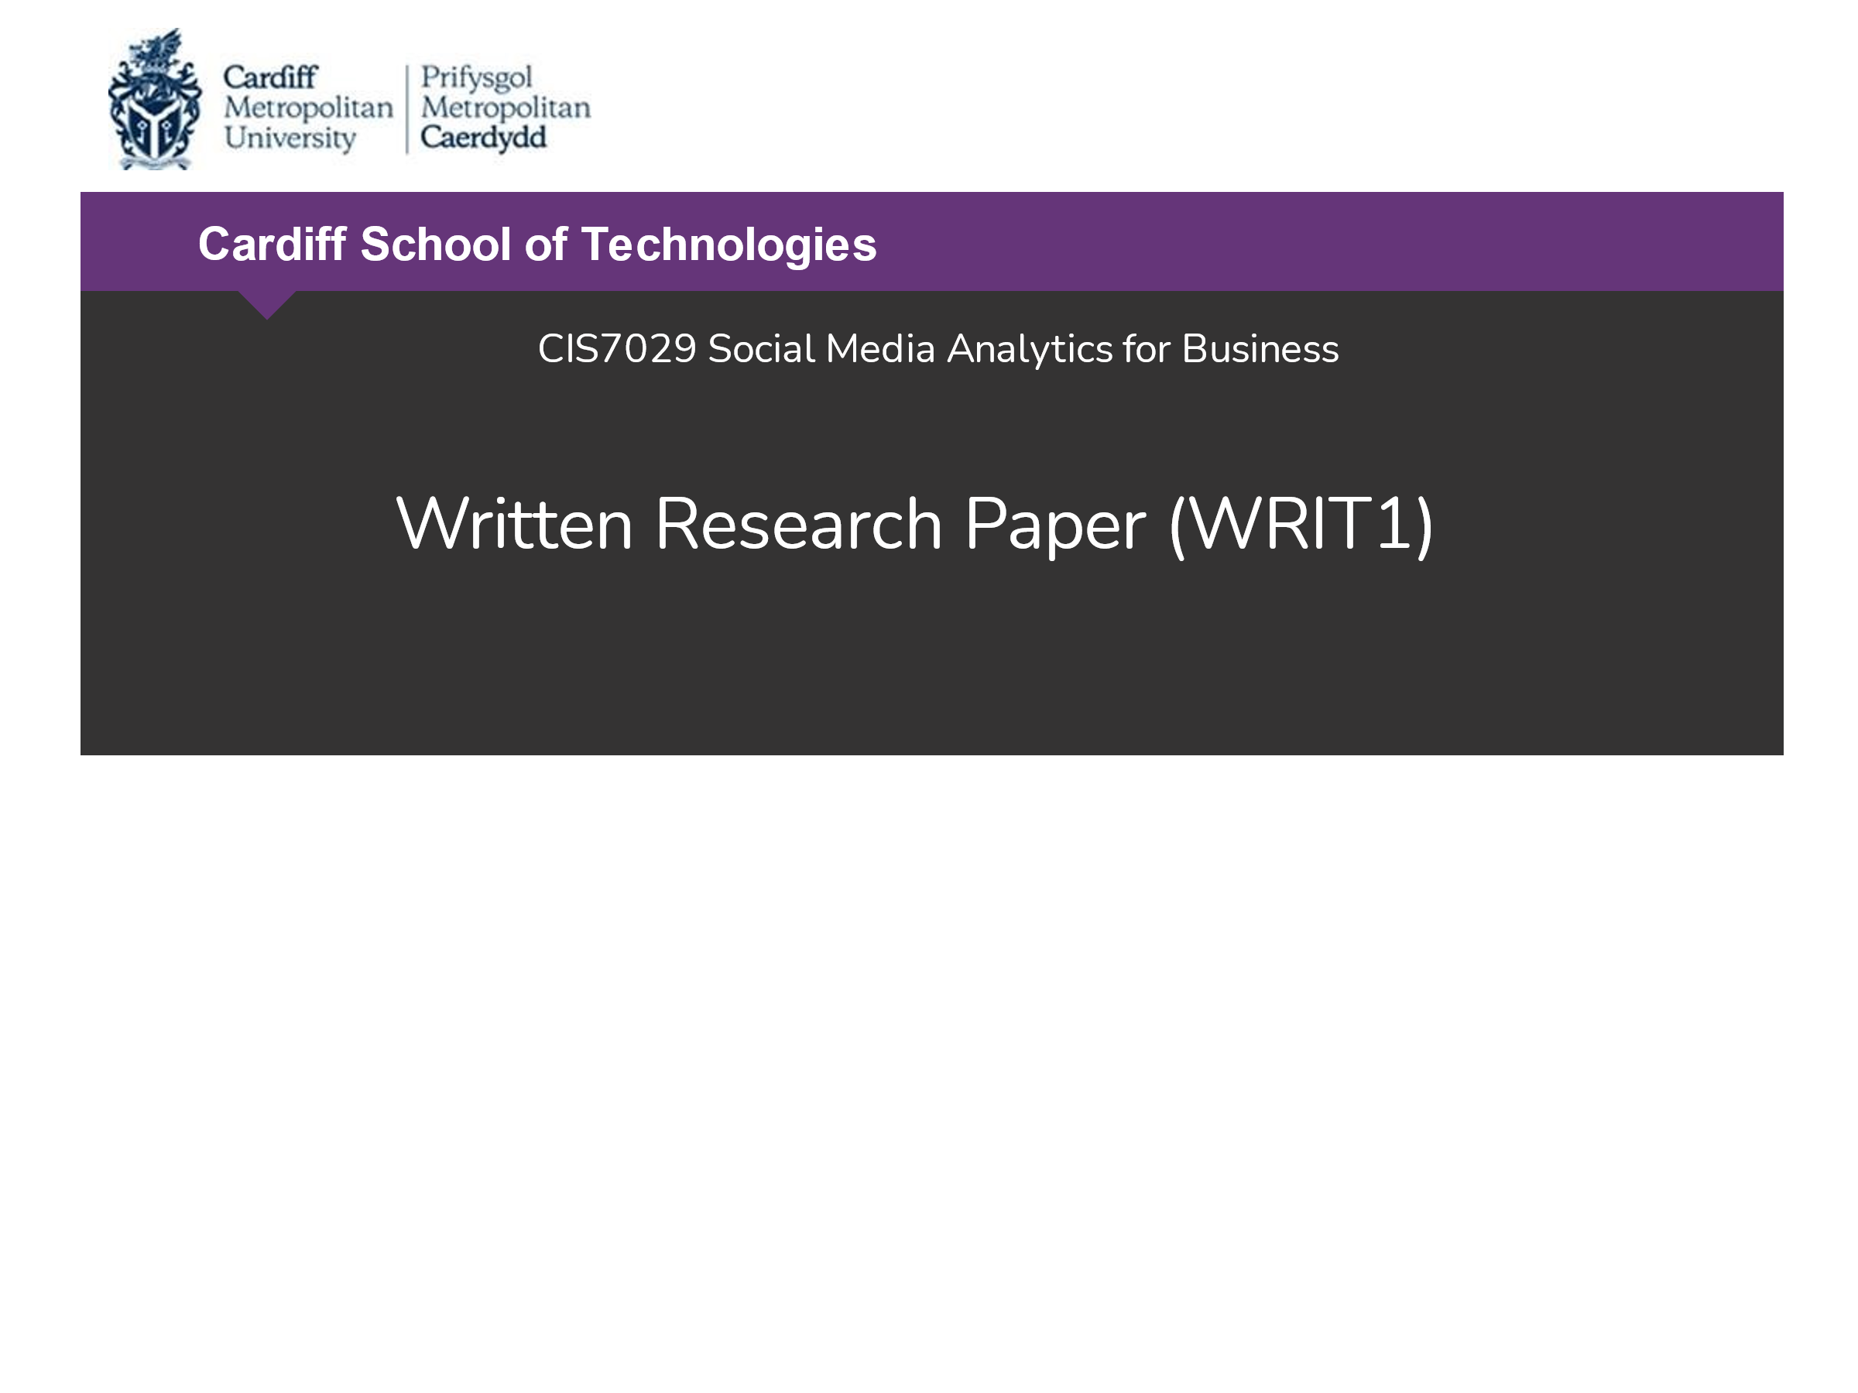

**Social Media Engagement Analysis of Higher Institutions in the UK**

(a case study of a top UK University)

by

**Soyinka ‘Sho’ Sowoolu**

st20219483

M.Sc. Data Science

May 2022

**Table of Contents**

List of Figures 4

List of Tables 5

1.0 Biography 6

2.0 Abstract 6

2.1 Purpose 6

2.2 Design and Methodology 6

2.2 Findings 6

2.3 Business Implication 6

2.4 Research Challenges and Limitations 6

3.0 Introduction 7

3.1 Preamble 7

3.2 Research Rationale and Motivation 7

3.2.1 Identification of case study institution 7

3.2.2 Research Motivation and Consideration Questions 8

3.2.3 Literature Review and Ethical Considerations 9

4.0 Research Design, Methodology, and Approach 10

4.1 Social Harvesting Tools 10

4.1.1 Python Language 11

12

4.1.2 Web Scraper (Chrome Extension) 12

4.1.3 Instant Scraper 13

4.1.5 Octoparse 14

4.1.6 Other web scraping tools 14

4.2 Social Media Data Harvesting Methodology 15

16

4.3 Social Media Data Harvesting 16

4.3 Data Cleaning and Output Formats 17

5.0 Key Results, Visualisation, and Business Story Telling 19

5.1 Analysis background 19

5.2 Key results analysis and Visualisation. 21

5.2.1 YouTube Channel 21

5.2.2 Twitter 21

5.2.3 Facebook 24

5.3 Discussions and Business Implications 29

6.0 Conclusions with Project Limitations and Recommendations 30

References 31

Appendices 33

List of Figures

**Figure 3.1** Search results for the top university in the United Kingdom

**Figure 3.2** Robots Exclusion Protocol (robots.txt) review of social media platforms of interest

**Figure 4.1** Python Selenium library used to extract tweet details from Twitter

**Figure 4.2** Identifying and copying Twitter element XPath for extraction with Python Selenium

**Figure 4.3** Scraping medium.com with Web Scraper Chrome Extension

**Figure 4.4** Instant Scraper showing data extract with its element in default name in HTML

**Figure 4.5** Octoparse free trial scrapes data off Twitter but does not get any data with Facebook and Instagram

**Figure 4.6** APIPY free profile gives little data from Twitter

**Figure 4.7** ParseHub tried for use to scrape Instagram but was not successful

**Figure 4.8** social media ScrapingResearch Project Design and Methodology

**Figure 4.9** Research Work Schedule Planning and Monitoring

**Figure 4.10** Tableau Prep-changing data types to correct formats

**Figure 4.11** Tableau Prep-creating calculated fields for better analysis

**Figure 4.12** Tableau Prep-data joins & unions for detailed output

**Figure 4.13** Microsoft Excel-VBA code for cleaning and custom formatting of time-based fields (YouTube video length)

**Figure 5.1** Multiple Social media accounts operated by the University of Oxford

**Figure 5.2** Top viewed video on the YouTube page of the University of Oxford

**Figure 5.3** Second highest viewed video on the YouTube page of the University of Oxford

**Figure 5.4** Twitter likes and retweets with the correlation and amplifications rates

**Figure 5.5** Twitter sentiment analysis for the past 24 hours

**Figure 5.6** Facebook videos engagement using views and likes

**Figure 5.7** Facebook video top viewed video also with high likes but short video length

**Figure 5.8** LinkedIn post with highest shares

**Figure 5.9** LinkedIn post with highest likes

**Figure 5.10** LinkedIn post with highest comments

**Figure 5.11** LinkedIn post with the highest average engagement rate and high amplification rate

**Figure 5.12** LinkedIn posts and their average engagement rates

List of Tables

**Table 3.1** Number of followers and subscribers on social media platforms of the University of Oxford as of March 2022

**Table 4.1** University of Oxford social media websites scraping and outcome

# Biography

I am a University Research Assistant who is influenced by seeking better ways to do things and live life. Based on this, I have progressed through a couple of professional tutoring which include a bachelor’s degree in Agricultural Engineering -sought out knowledge about better and more efficient ways to feed the world, MBA in Production Planning and Control-motivated by having better and more efficient business operations and processes. I did an M.Sc. in Data Science to know how data can be harnessed as a resource for a better and more efficient business and living. So, this current research was undertaken with the broad motivation of what the new age of social media is contributing to the dissemination of knowledge within the Ivory Towers.

# Abstract

## 2.1 Purpose

This research sets out to see if social media can be justly added as an engagement platform for universities to propagate knowledge through taught courses and research? Can web harvesting be used to confirm the alignment of this strategy?

## 2.2 Design and Methodology

To effectively cover the purpose, the research was designed to have a broad range of social media platforms for data collection and analysis applications. As such, custom programs using the python language libraries were written as well as free Chrome extensions add-ons and subscription-based third-party tools.

## 2.2 Findings

In the light of the limitations and challenges narrated below, we were able to get enough information to justify that while social media is a workable engagement media for universities based on the data collected from the social media platforms of the University of Oxford, the social media platforms currently being used more as a marketing and brand awareness outlet.

## 2.3 Business Implication

Universities can lean on social media to carry out knowledge radiation to their students as well as have a process to conscious monitor its effects to have a continuous improvement mechanism in place.

## 2.4 Research Challenges and Limitations

Web harvesting while having myriad values to all parties has been a controversial area in respect of allowing others to access our social media data. In the light of this, each social media platform had its peculiar ease or otherwise to effectively harvesting any or all the data available within it

**Keywords:** social media; Web Scraping; Web Harvesting; Crawlers; social media Data.

# Introduction

## 3.1 Preamble

This flexibility of selection of a topic with application of social media analytics to business issues or application within transportation or education invoked a deep thought to see how social media can influence performance or efficiency within any of these sectors we decide to research into. Personal passion for academics made it easy to narrow down the sector of interest to education and where else is best to influence education than in the Ivory Tower.

Social media presence is now a bandwagon to be on for almost every individual and organization, it might be just to assume that a lot of other people get on social media as part of their strategic objectives for growth. So, we believe universities have social media as part of their purpose fulfilment. The purpose of a university or college has been intricately tied to the service of the perceived needs and requirements of society at the time, whether these were related to religion or very secular matters of governance and the economy. (William M. Bowen, Michael Schwartz, and Lisa Camp, 2014)

## 3.2 Research Rationale and Motivation

### 3.2.1 Identification of case study institution

The university selected must have noteworthy influence or position among other universities to be able to be accepted as being a representation of the whole.

A search query list of the top universities in the United Kingdom (UK) was done on the google search engine and based on University League Tables 2022 published online, the University of Oxford was listed as the No.1 university in the UK (*University Rankings and League Tables 2022*, no date).

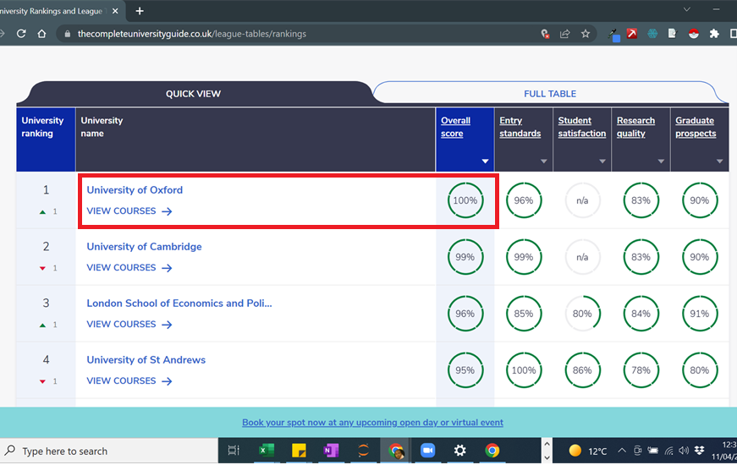

**Figure 3.1** Search results for the top university in the United Kingdom

To progress, the University of Oxford was selected to be the object of study for this research towards justifying the motivation and discovery objectives.

### 3.2.2 Research Motivation and Consideration Questions

With our case study in place, our motivation is then that since most universities are active are on social media which is confirmed by the statistics from the social media accounts of the University of Oxford shown in Table 1.1 below. We, therefore, formulated the following research questions:

**Research Questions**

* What is the main type of engagement or activities happening on these SM platforms?
* Can SM be identified as another platform of learning or research for higher educational institutes?

These research considerations thus guided our work when analysing the social media data harvested from the social media platforms of YouTube, Facebook, Twitter, Instagram, LinkedIn, and Medium maintained by the University of Oxford.

|  |  |
| --- | --- |
| **Social Media Platform** | **Followers/Subscribers** |
| YouTube | 255,000 |
| Facebook | 4,502,130 |
| LinkedIn | 809,435 |
| Instagram | 1,100,000 |
| Medium | 17,000 |
| Twitter | 809,000 |

**Table 3.1** Number of followers and subscribers on social media platforms of University of Oxford as of March 2022

### 3.2.3 Literature Review and Ethical Considerations

It is a necessary part of this study to ensure that all the work to be done is done within the confines of both regulations and ethics.

It is extremely easy to relate or confuse web scraping or harvesting with computer hacking-the term used to describe that unlawful access or collection of information from computer systems either as a hobby or as a crime. However, accessing information that is public knowledge, which is not a secret should not be hacking and web scraping should not be classified as such(Macapinlac, 2018).

It can still be argued that there is a thin line drawn in the consideration of whether scraping social media data is a form of hacking. While some of the data from these platforms are available to the public, some of the data are only visible to the account holder, while some are also only visible to the owners of the platform. For example, for a platform like Facebook, as a third party you can see the number of followers, posts, the number of views of posts and likes, etc. on another account, however, information like the geographical reach of posts, personal details (not shared publicly), impressions of posts, etc. are not visible to you as a third party (*Insights | Facebook Help Centre*, no date). These platforms also track activity data not just those shared by you. So, could scraping such data not made publicly available by the social media platform be illegal? Good to note most of this information is still supplied publicly by these platforms for a fee.

It is thus common for platforms to decide what part of their platform if any, that data can be scraped from. This is achieved by having a Robots Exclusion Protocol which is a plain text file named *robots.txt* which has a set of instructions (called directives) for web crawling robots on how and what they can scan, scrap, or crawl on the site (*Robots.txt: Definition and How to Master it*, no date)

A robots.txt query conducted on all the social media platforms to be analysed revealed a lot of restrictions on the data that can be scraped freely (figure 3.2). Be that as it may, with the object of the scraping being purely academic, the scraping was gone ahead with. It has been noted that one of the most used data collection techniques for research is web scraping (Li, Zhou, and Cai, 2021)

In recent years, university and college research and development has seen a renewed attention to the progressive use of social media to support learning activities and their assessment that coincides with but is not wholly attributed to, the rising importance in broader society of Web 2.0 and social media (Tay and Allen, 2011). While online internet-based teaching had kicked off before the peak of lockdowns due to the coronavirus pandemic in 2020, this period enforced and confirmed the use of online resources for academic education. From the literature reviewed by (Ssekiziyivu, Mukoki and Musoke, 2021) it was noted that discussions of concepts and their examination with peers can be done, and easily receive feedback through social media platforms.



**Figure 3.2** Robots Exclusion Protocol (robots.txt) review of social media platforms of interest

# Research Design, Methodology, and Approach

## 4.1 Social Harvesting Tools

As the need for web scraping increased, so also did the business justification for building specialist tools that could be used with little or no knowledge of programming languages. Therefore, web scraping can be achieved either by manually coding a custom program or by machine scraping -using a purpose-built application.

### 4.1.1 Python Language

Python is an easy-to-use programming language in great use for a lot of applications as it has a rich ecosystem of tools for many tasks (*Introduction | Python Web Scraping Cookbook*, no date). The Python libraries utilised for the work are BeautifulSoup, Selenium, and Request.

***Justification for use:***Python can be used solely for social media web harvesting. Meanwhile, the high level of proficiency required for complex situations and currently not yet attained also necessitated supplementing this with purpose-built add-ons and third-party purpose-built applications like Instant Scraper, Web Scraper, Data Miner, Octoparse

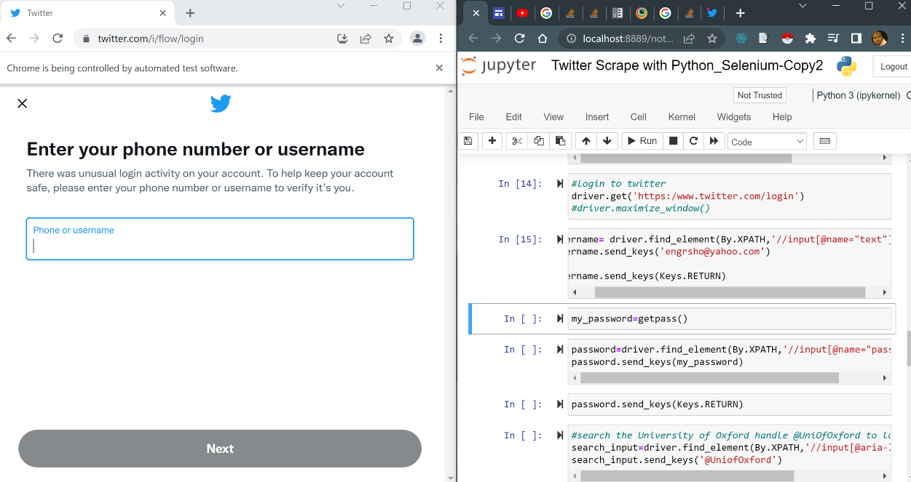

**Figure 4.1** Python Selenium library used to extract tweet details from Twitter

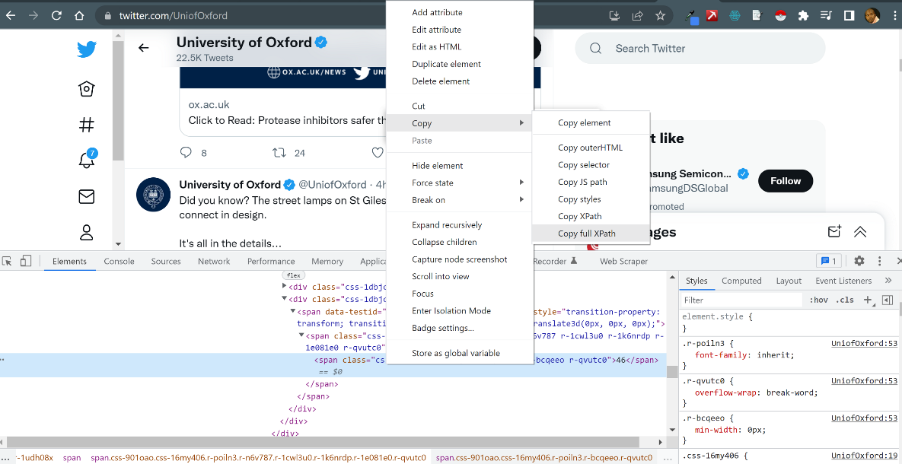

### 

**Figure 4.2** Identifying and copying Twitter element XPath for extraction with Python Selenium

### 4.1.2 Web Scraper (Chrome Extension)

Just as when using Python, some basic knowledge or appreciation of HTML and CSS is desired to be able to find the elements and tags holding the data of interest that you would like to extract.

***Justification for use:***The relatively easy installation and 100% free access made it a tool of interest however, it is disabled for most popular social media sites such as Facebook, YouTube, Instagram, etc. in addition to the deeper knowledge needed to scrape complex webpages.

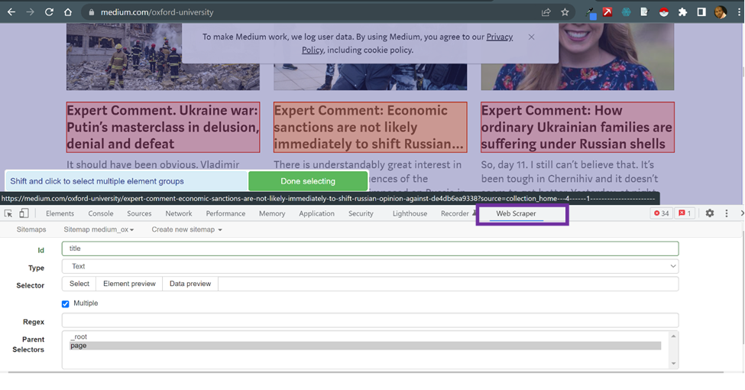

**Figure 4.3** Scraping medium.com with Web Scraper Chrome Extension

### 4.1.3 Instant Scraper

It requires you to be able to find what the element name extracted pertains to since they scraped with default names as available in the HTML code as highlighted in Figure 4.2

***Justification for use:*** It is an automated system requiring no coding skills even though this will be helpful to make sense of some of the extracted data from complicated web pages e.g., Facebook which intentionally uses JavaScript to change the names of elements as the page loads. It is also able to handle pages that paginate by infinite scrolling down on the page.

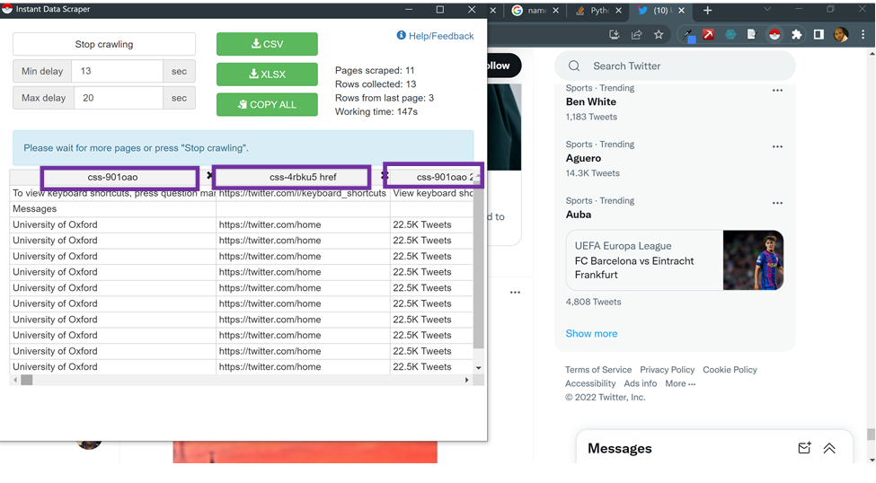

**Figure 4.4** Instant Scraper showing data extract with its element in default name in HTML

4.1.4 DataMiner

DataMiner is a tool that is provided as a browser extension and does not require any programming skills. Using the tool requires a little learning curve but it is very intuitive. Data miner uses what it calls recipes which are unique HTML instructions to scrape websites. It holds the names and location of HTML elements on the page (*How Data Miner Extension Works | Data Miner*, n.d.).

**Justification for use**: There is no need for coding skills and works well on multiple web pages paginated sites. Nonetheless, the ability to scrape websites that render their HTML contents with JavaScript and some domains is provided as a paid service and not available in the free package.

### 4.1.5 Octoparse

This is another tool that allows you to scrape websites without any coding skills required. The data is scraped with a simple point and click. Octoparse works well on websites with infinite scrolling, login, drop-down, AJAX, etc.

**Justification for use:** This is an extremely powerful tool for someone with limited programming knowledge to scrape, it also provides an automatic IP rotation to prevent IP from being blocked. With such useful features, the tool is available as a paid subscription, however, the 14 days trial terms made it accessible for use for the research.

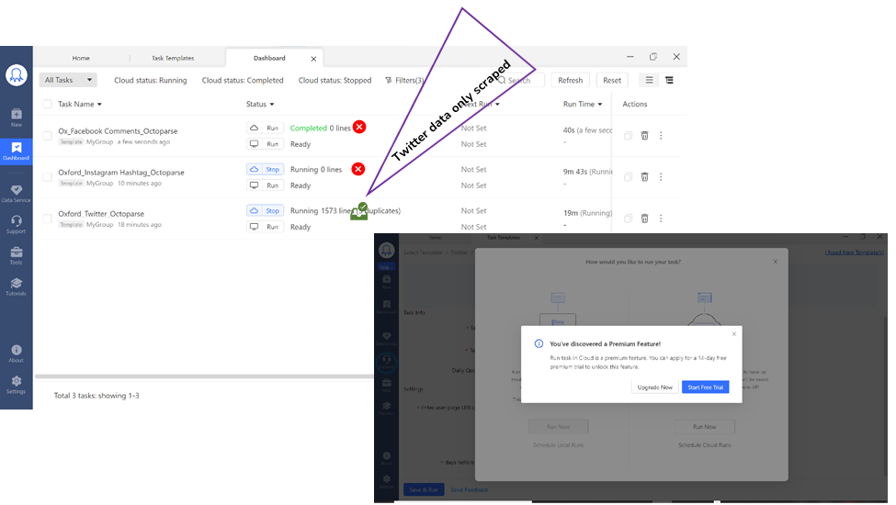

**Figure 4.5** Octoparse free trial scrapes data off Twitter but does not get any data with Facebook and Instagram

### 4.1.6 Other web scraping tools

APIPY is also a Python-based tool, and it was applied to scraping Twitter. The free package was extremely limited and produced little data and it was not worth the while trying to explore further to scrape other social media platforms (Figure 4.6). Similarly, ParseHub when used looked as if it would be able to scrape some data from a site such as Instagram, but the package was not very intuitive to get proficient in it within the time available. See Figure 4.7 for an attempt made at using ParseHub. The following were also perused:

* Scrapy.org
* 80legs.com

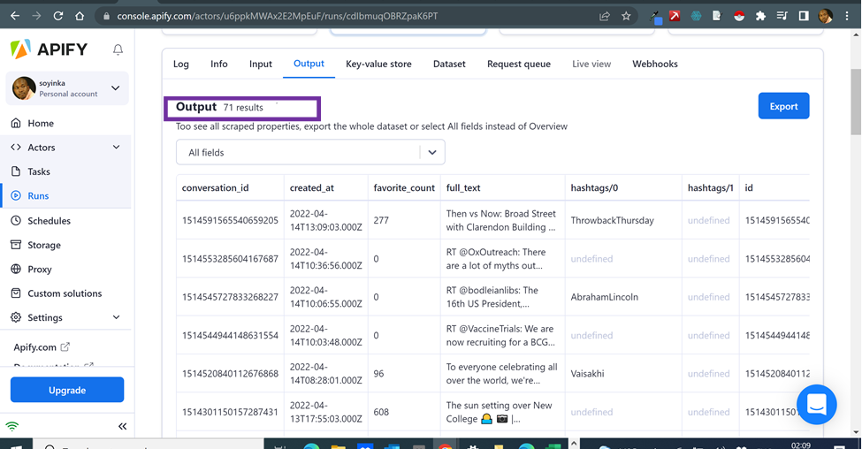

**Figure 4.6** APIPY free profile gives little data from Twitter

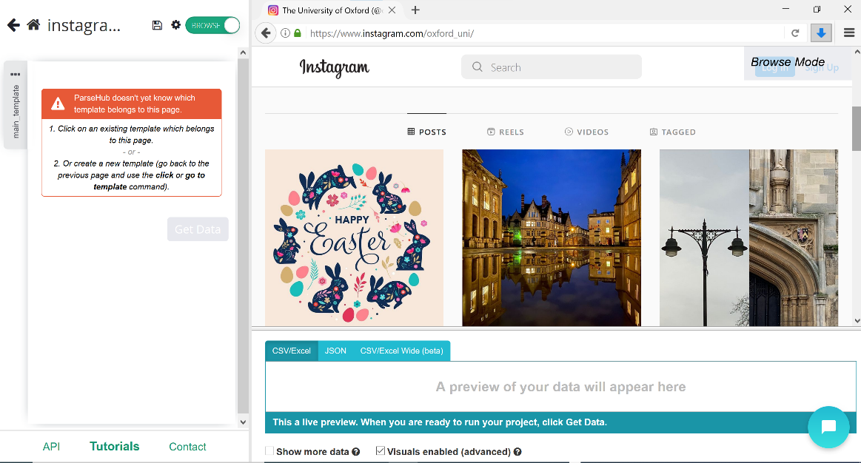

**Figure 4.7** ParseHub tried for use to scrape Instagram but not successful

## 4.2 Social Media Data Harvesting Methodology

Once the social media tool was identified, a methodological approach was formulated to plan, execute, and monitor the research work up to completion. The design is presented in Figure 4.8 whereby, the work progressed from topic selection, web scraping, data cleaning and transformation, and visualization to analysis and findings reporting.

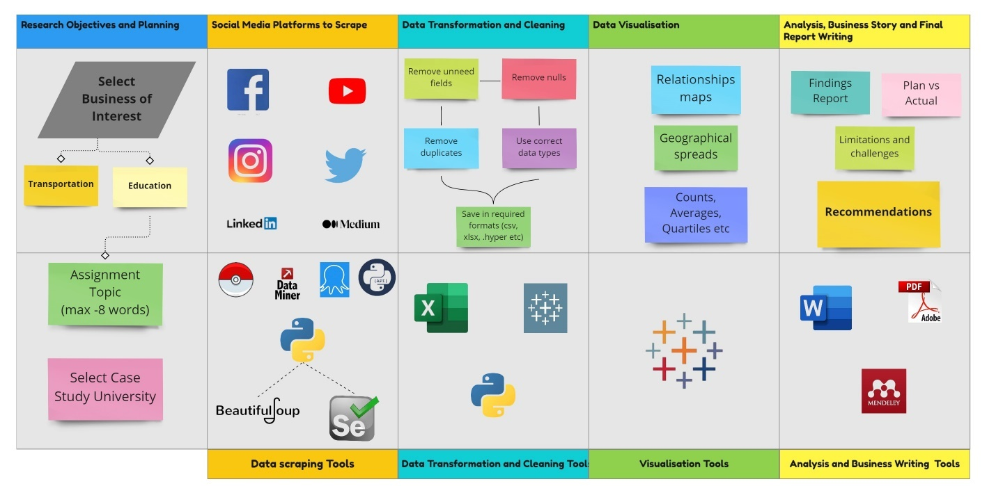

**Figure 4.8** social media ScrapingResearch Project Design and Methodology

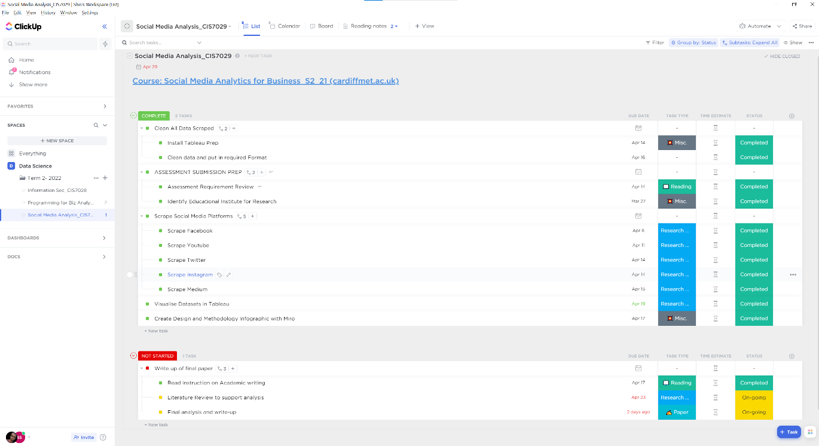

## 

**Figure 4.9** Research Work Schedule Planning and Monitoring

## 4.3 Social Media Data Harvesting

The outcome of scraping these social media platforms of the University of Oxford is summarised in Table 4.1 below.

|  |  |  |  |  |
| --- | --- | --- | --- | --- |
| **SM Platform** | **Link to account** | **Tool(s) Used to Scrape** | **Output Good (Yes/No)** | **Data Visualisation Processed? (Yes/No)** |
| YouTube | https://www.youtube.com/c/oxforduniversity | DataMiner | Yes | Yes |
| Python | Yes | Yes |
| Facebook | https://www.facebook.com/the.university.of.oxford | Instant Scraper | Yes | Yes |
| Twitter | https://twitter.com/uniofoxford | Octoparse | Yes | Yes |
| APIPY | Yes* | Yes |
| Instagram | https://www.instagram.com/oxford_uni/ | Instant Scraper | Yes | Yes |
| Medium | https://medium.com/oxford-university | Web Scraper (Chrome Extension) | No* | No |
| LinkedIn | https://www.linkedin.com/school/oxforduni/ | Instant Scraper | Yes | Yes |

* Data scraped was scanty and for medium.com this was too small to justify any visualisation.

**Table 4.1** University of Oxford social media websites scraping and outcome

## 4.3 Data Cleaning and Output Formats

Output from the scraping exercise was both in excel -XLSX, and CSV. Visual inspection of the data warranted cleaning and pre-processing activities to be carried out on most of the datasets derived before using them to create visualisations. The volume of each set of data and its peculiarity was a factor in deciding which cleaning or data preparation tool to employ for the task. To this end, Microsoft Excel and Tableau Prep were utilised. At some point, there was a need to use Excel VBA code to achieve the level of clean data desired.

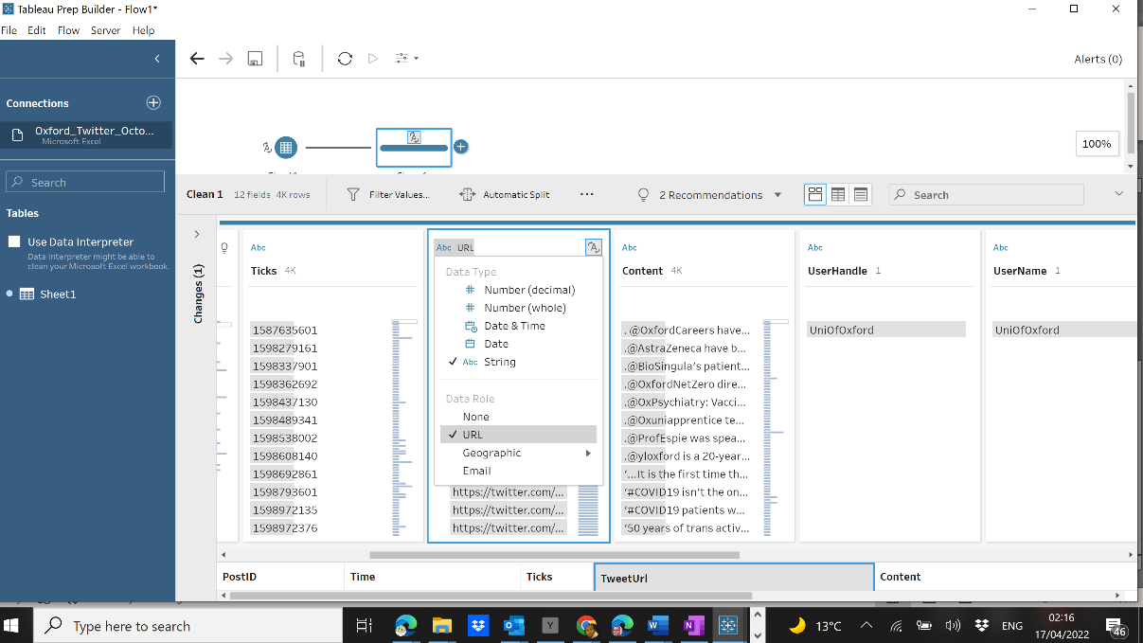

**Figure 4.10** Tableau Prep-changing data types to correct formats

Cleaning operations carried out included removing null values, removing stranded letters/characters, and changing data types (e.g., strings to integers or decimals, etc.).

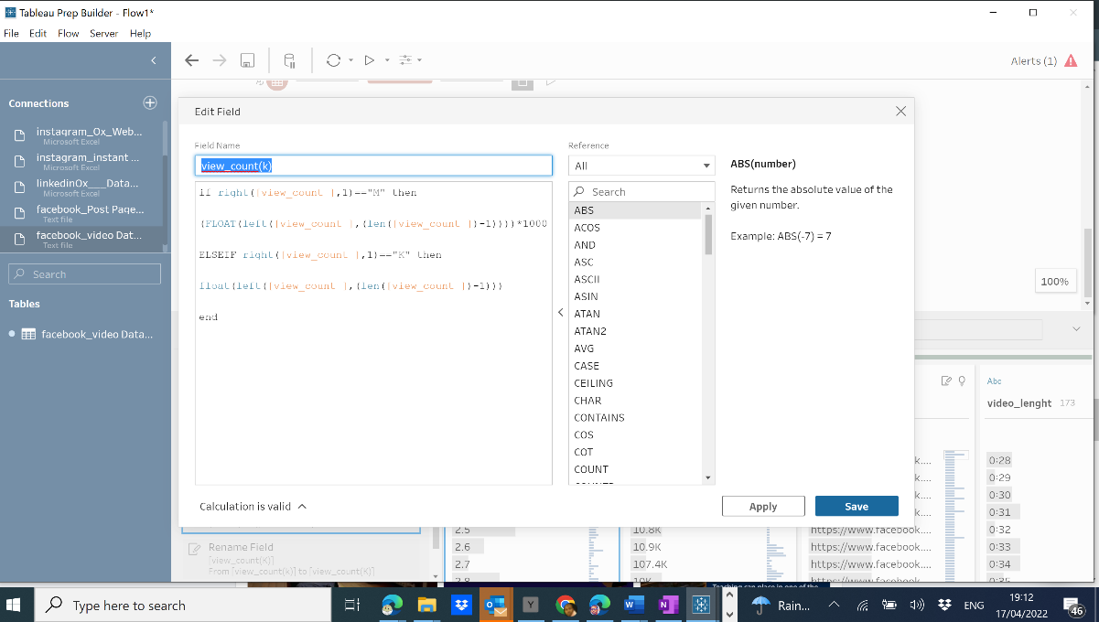

**Figure 4.11** Tableau Prep-creating calculated fields for better analysis

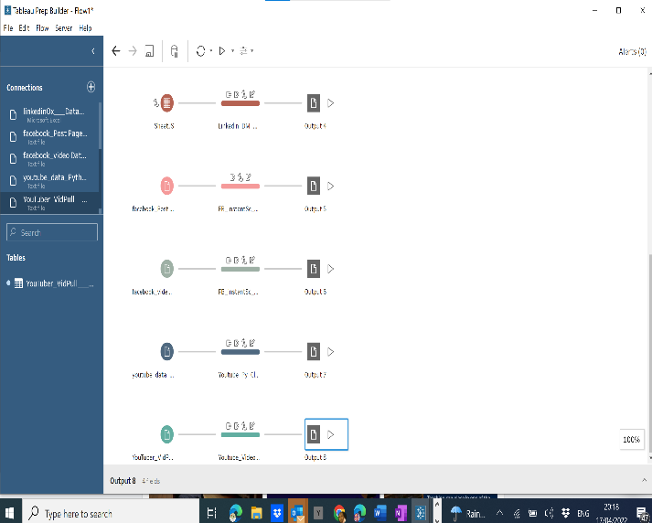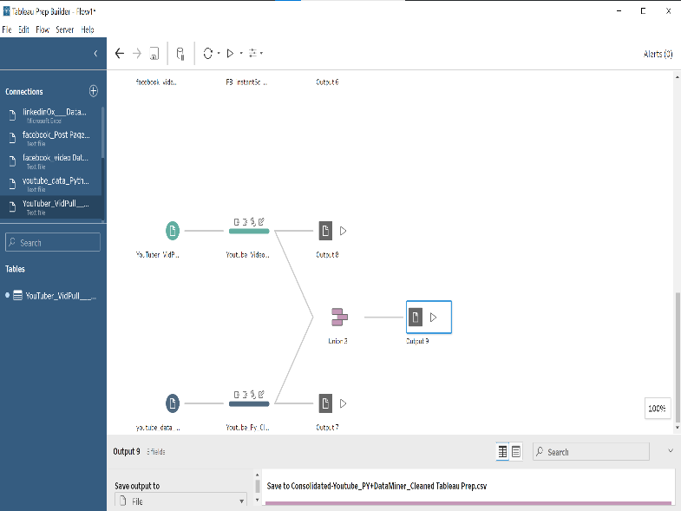

**Figure 4.12** Tableau Prep-data joins & unions for detailed output

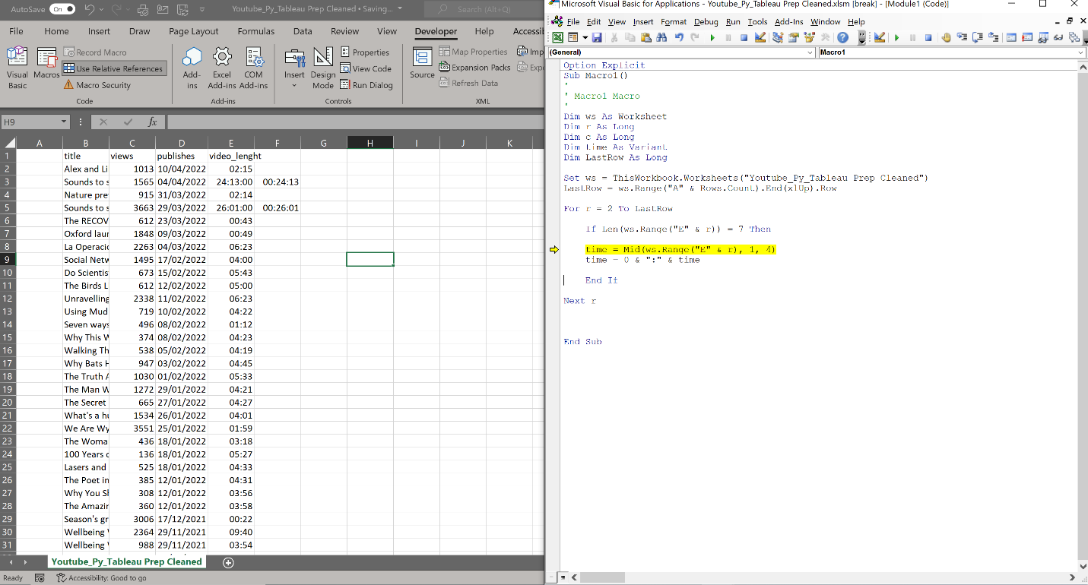

**Figure 4.13** Microsoft Excel-VBA code for cleaning and custom formatting of time-based fields (YouTube video length)

# Key Results, Visualisation, and Business Story Telling

## 5.1 Analysis background

Social media is being used for facilitation, marketing and brand awareness, recruitment, collaboration, surveying, teaching, and learning tools, career management and generally establishing relationships with stakeholders and interested parties (del Rocío Bonilla *et al.*, 2019)

The formats of content allowed are usually a way to define the platform that is, whether videos, images and text either direct or with external links. Most entities will have accounts across the various platforms which is the case with the University of Oxford. Figure 5.1 shows their social media presence (the University of Oxford, n.d.).To this end, each of these has generated several research topics to address or investigate their use so it is apparent that our output for this work will be holistic at best.

To fulfil our research objective to find out if social media was playing a role as an educational platform there was a need to be able to identify and classify the contents posted on these platforms and, confirm the type of engagement the users are having with the content post and trends of this.



**Figure 5.1** Multiple Social media accounts operated by the University of Oxford

Content posts for a university can be at a high level be divided into:

* News/Information
* Educational (lecture/research outcomes)
* Marketing/Promotional
* Brand Awareness

Further work would also be required to classify the parties engaging with the material whether they are students, staff, or external parties to the university. Based on this, the research objective was streamlined as a first step to getting an understanding of the engagement performance of the platform with interested parties.

This is achieved by creating visuals of the data extracted for the social media platform. Each platform has its way of collecting engagement data -LinkedIn (Likes, Shares), Facebook (Views, Likes, Shares), YouTube (Views, Likes, Comments), Instagram (Likes, Comments), etc. While there are other ways to gauge engagement, a commonly used measure is the amplification rate. This is a computation of the shares a post generated divided by the count of followers of the account. This figure is converted to a percentage by multiplying by 100. This gives a ratio of people that liked the post enough to share it with all the followers (*5 of the Easiest Ways to Make Data an Integral Part of Your Business’ Digital Marketing*, no date). Closely related is the average engagement rate which is the number of engagement actions (e.g., likes, shares, comments) a post receives relative to the total number of followers. From the data collected, we have calculated these two metrics for analysis (*19 Social Media Metrics That Matter—And How to Track Them*, no date)

## 5.2 Key results analysis and Visualisation.

### 5.2.1 YouTube Channel

The collected engagement data are the views, likes and comments. To identify each post the URL was extracted which also gave the title. However, classification of each video into the earlier mentioned classes of news and/or information, educational (lecture/research outcomes), marketing/promotional and brand awareness could not be achieved in this research. The title at best is what we would use to identify or classify the type of content in the video is. The length of the video was also extracted to compare this to the number of views and likes generated since as we can loosely relate the length of a video to a type of content- *an educational content will usually be a long video*.

In figure 5.2 below, the video “*Richard Dawkins vs Rowan Williams-Humanity’s ultimate origins”* generated the highest views at 1,263,491 but unfortunately, the likes data were not extracted. This content can be classified as educational by looking at its title and a quick view of the video. The length of the video is at 1hour and 28 minutes which is long enough to deliver educational or intellectual content. However, analysing the second highest viewed video departs from this. This is a short video with a length of 1 minute 30 seconds showing how the Cockatoo bird makes tools from different materials (Figure 5.3). Can we not argue whether this is educational or informational content?

The data extraction process needs to be updated to be able to get the likes, dislikes, and shares data for each video for more insight into how the video was interacted with by interested parties.

### 5.2.2 Twitter

Analysing the Twitter handle of the University of Oxford as shown in Figure 5.4 below, the likes and retweets counts were directional proportional. That is tweets generate almost equal numbers of likes and retweets. This is not an uncommon situation as you would usually retweet what you like. The assumption here with Twitter is that for a tweet that does not earn a like or retweet it’s either it is disliked or no opinion at all on it which are both treated as no opinion.

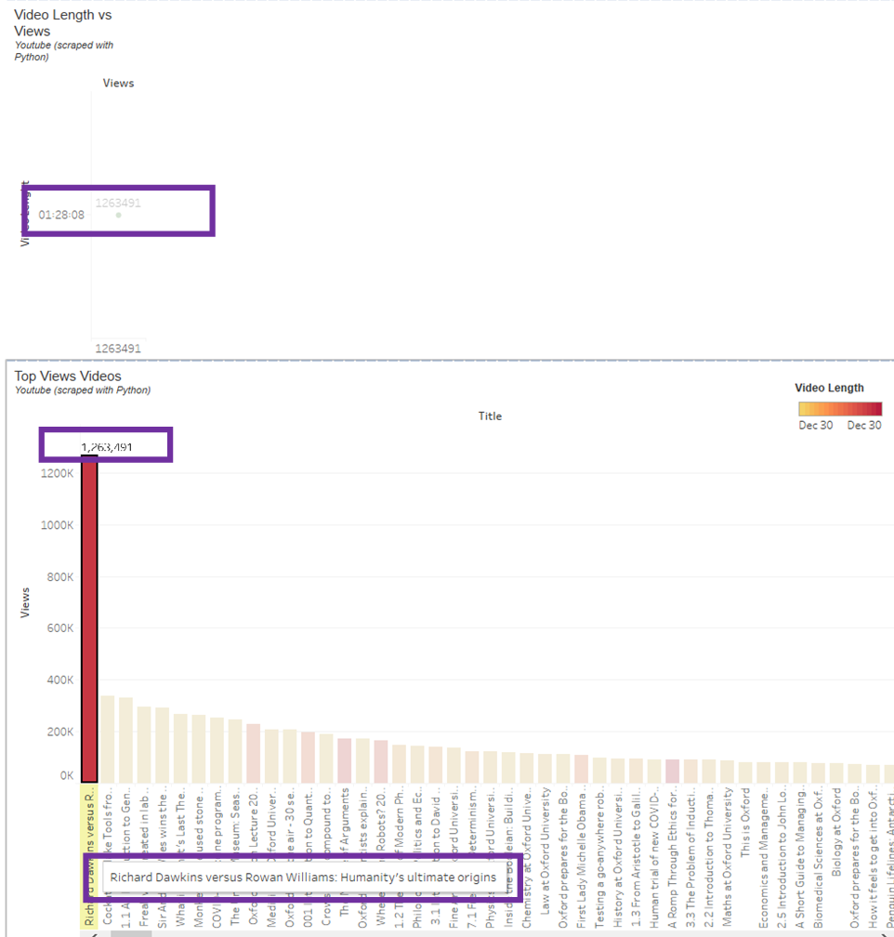

**Figure 5.2** Top viewed video on YouTube page of the University of Oxford



**Figure 5.3** Second highest viewed video on YouTube page of the University of Oxford

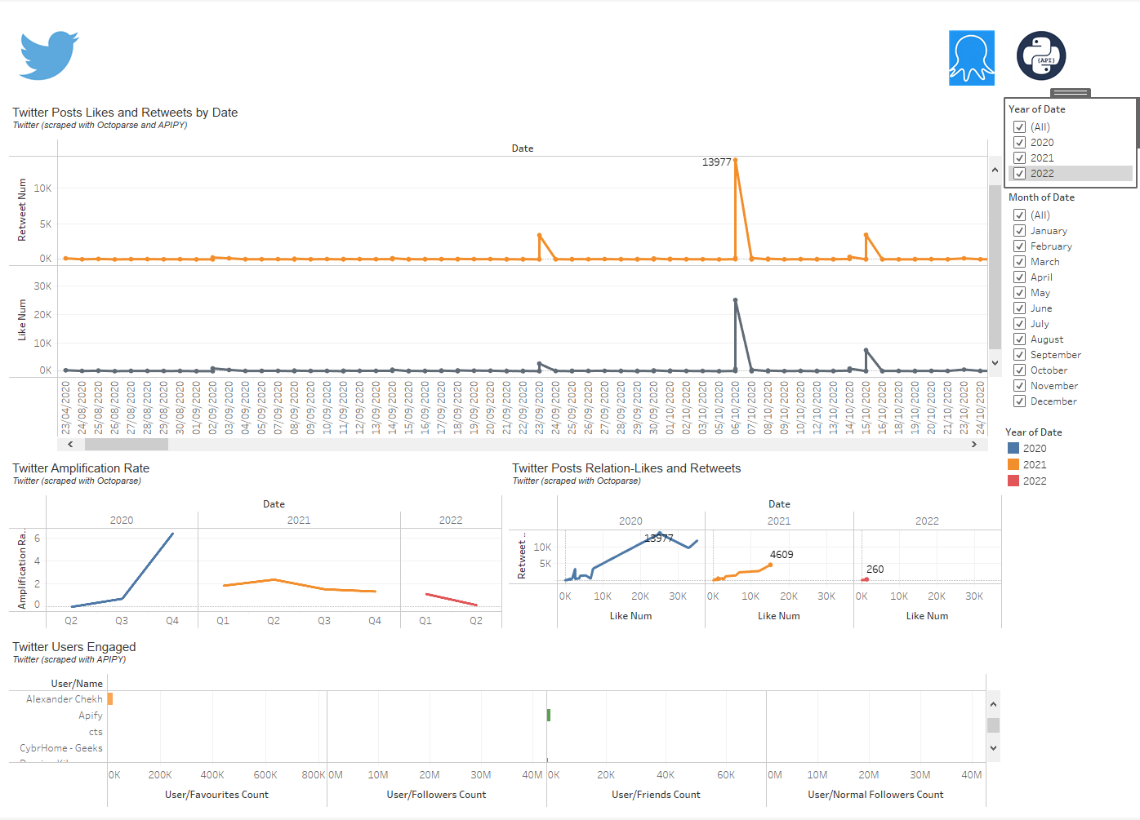

**Figure 5.4** Twitter likes and retweets with the correlation and amplifications rates

From the dashboard above, we see that there is a downward trend in the engagement on the Twitter platform in 2021 and 2022 compared to 2000. In 2020 the Amplification rate which is a percentage of the sum of all the shares divided by the total followers grew up to 6.4% by the end of Q4 2020. This grew from 1.8% in Q1 2021 to 2.4% in Q2 2021 before dropping to 1.4% by end of 2021. In the current year as well, there has been a downward trend from the beginning of the year to date.

While the work plan did not include doing sentiment analysis, this outcome prompted the need to do a quick peep into how people were reacting to the University of Oxford generally on Twitter (Figure 5.4).

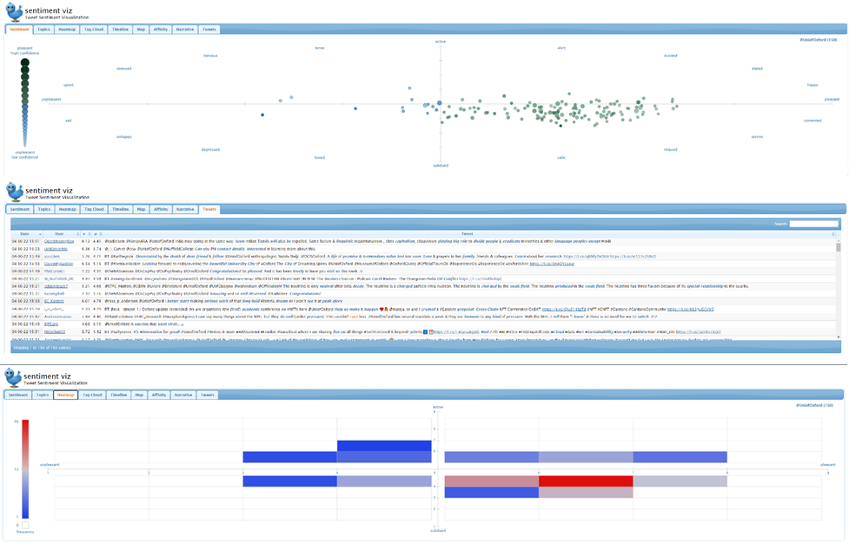

**Figure 5.5** Twitter sentiment analysis for the past 24 hours

### 5.2.3 Facebook

To deliver intellectual or academic content full text on Facebook might not be interactive in an opinion. Maybe with this in mind Facebook has a separate page for videos for account holders. Putting this into consideration, the scraping activity was thus concentrated on harvesting the Facebook video page of the University of Oxford. The data point available for analysis from this is the length of the video, the likes and the views generated by each video (Figure 5.5).

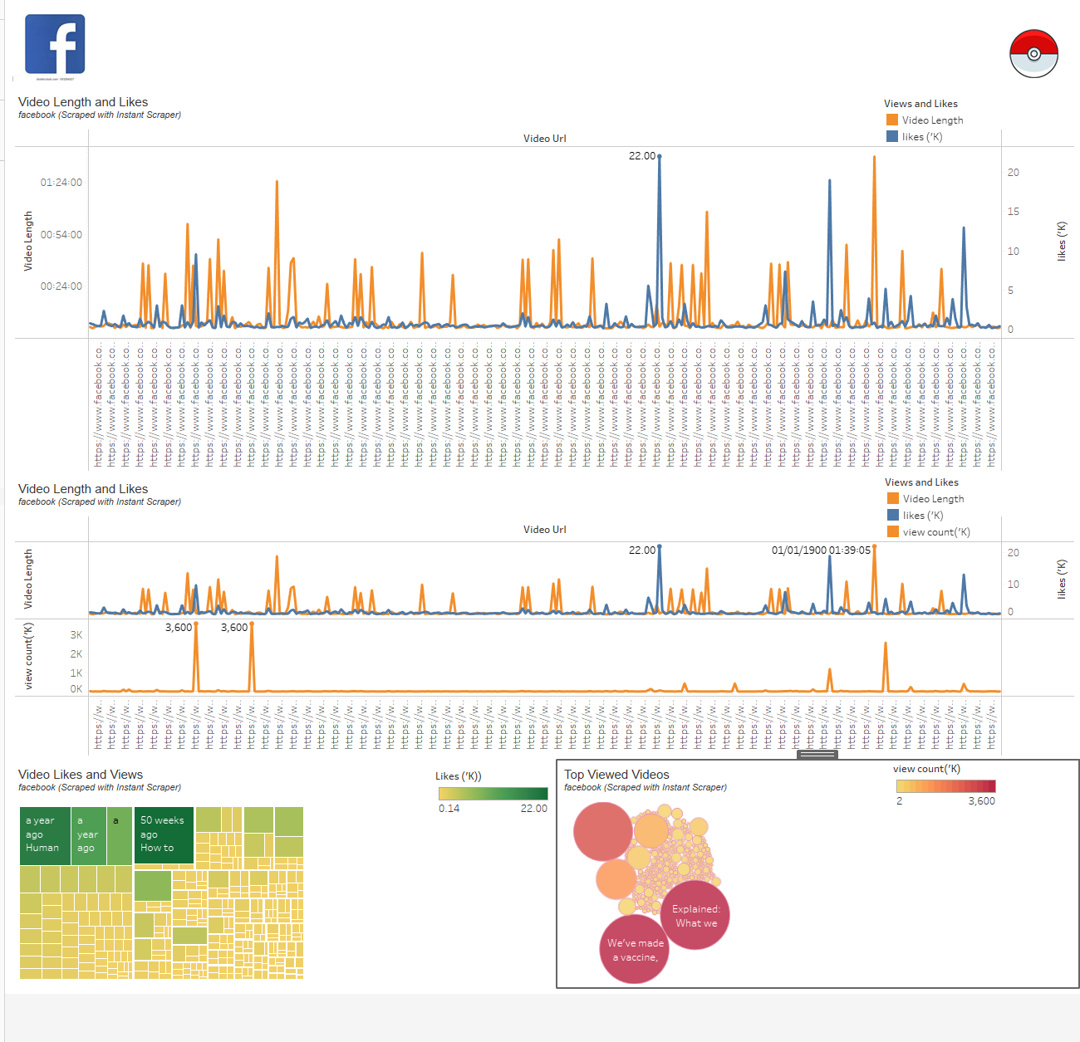

**Figure 5.6** Facebook videos engagement using views and likes

From the dashboard, we can see that the videos with top views are relating to Covid-19 issues, and these are short length videos. The highest viewed video is 1 minute 23 seconds long and this also generated a high number of likes- 9,600. See figure 5.6 below. This is a confirmation that without an effective view into the categorization of the videos rather than using video length the integrity of the proposition will be suspect. What comes without argument is that there is a lot of engagement with their content on the Facebook platform.

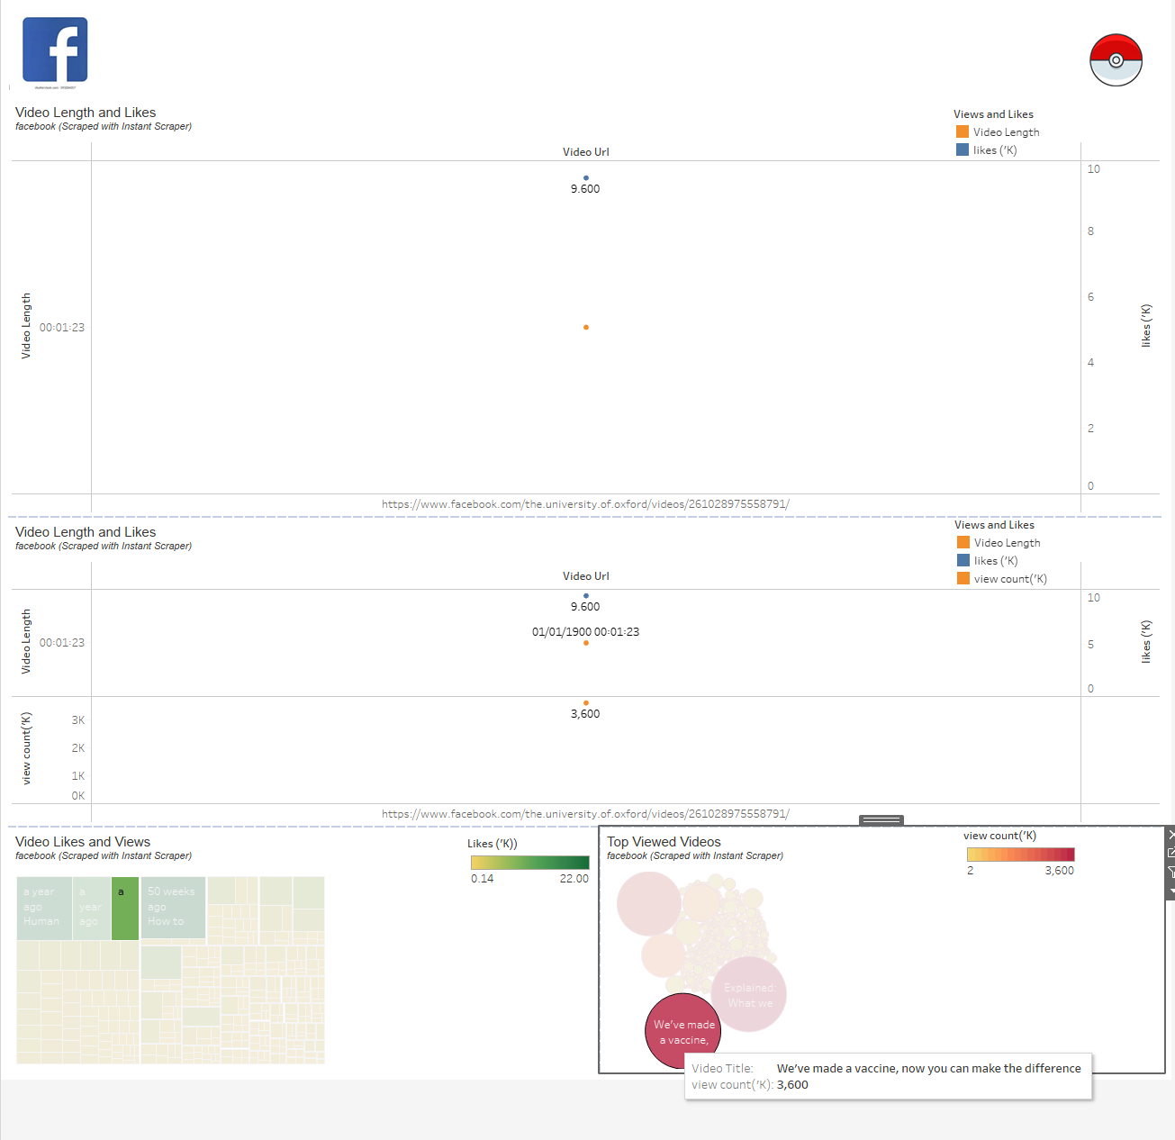

**Figure 5.7** Facebook video top viewed video also with high likes but short video length

5.2.4 LinkedIn

The University of Oxford also maintains a LinkedIn account which is well followed, and they also have a lot of staff maintaining profiles on LinkedIn as well. Unlike the Twitter platform, the shares and likes are not directionally proportional as a share is the same process as a retweet. The LinkedIn post is not identifiable as a video, text or image, URL link or combination of these so, we can only rely on the title to do a categorization to find out if the content is educational or otherwise. Figures 5.7, 5.8, 5.9 and 5.10 below shows that the post with the highest shares, likes and comments are all different.

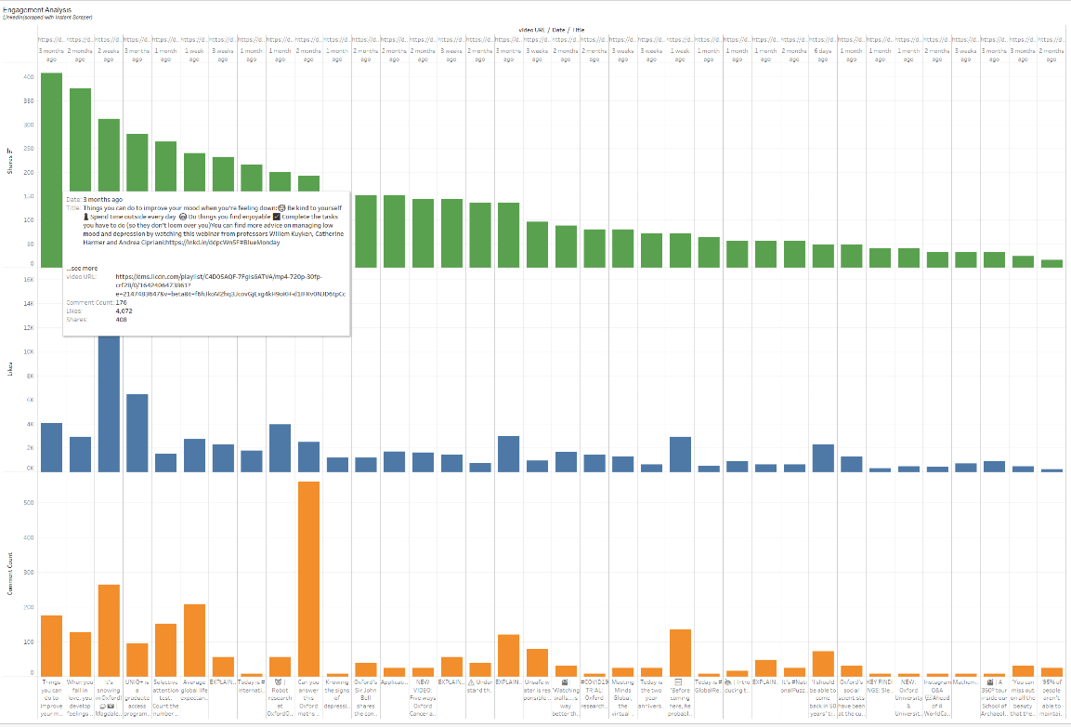

**Figure 5.8** LinkedIn post with highest shares

There is however as expected a correlation between the average engagement rate and the amplification rate. The post with the highest average engagement rate was about the weather in Oxford (Figure 5.8)

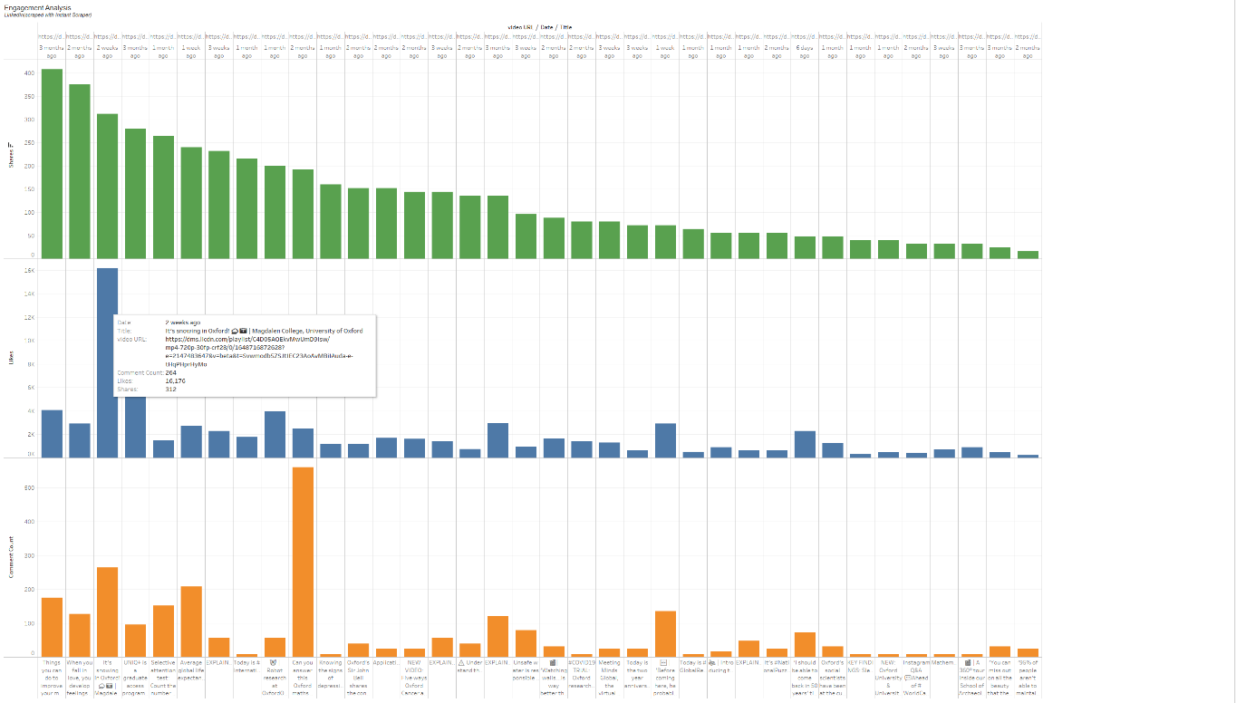

**Figure 5.9** LinkedIn post with highest likes

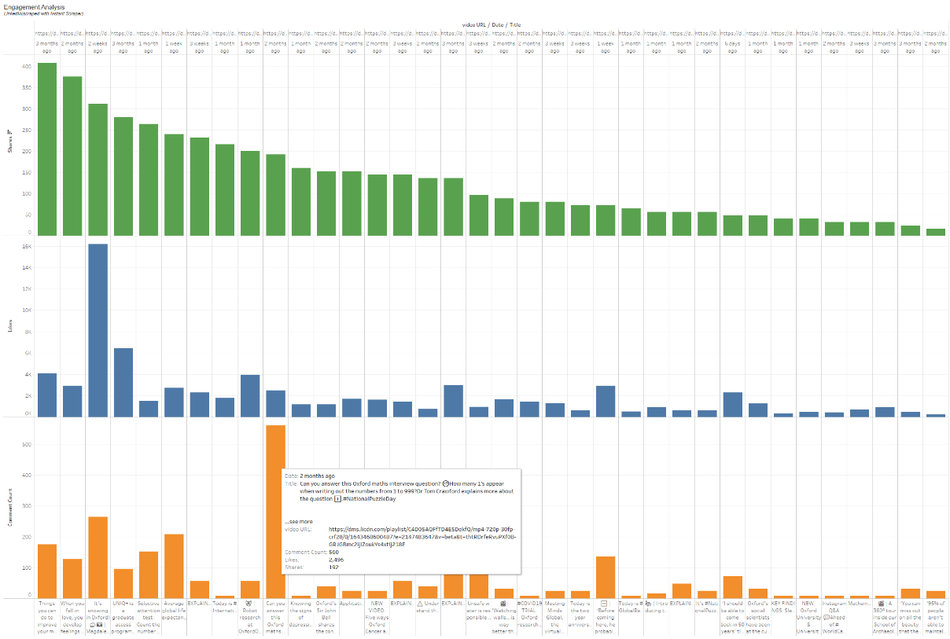

**Figure 5.10** LinkedIn post with highest comments

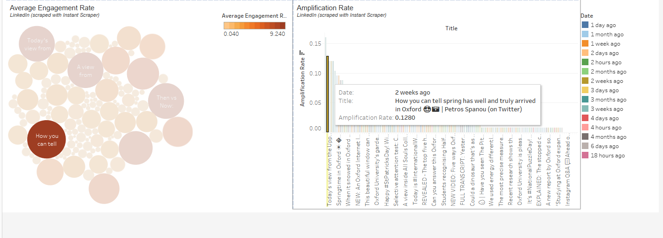

**Figure 5.11** LinkedIn post with the highest average engagement rate and high amplification rate

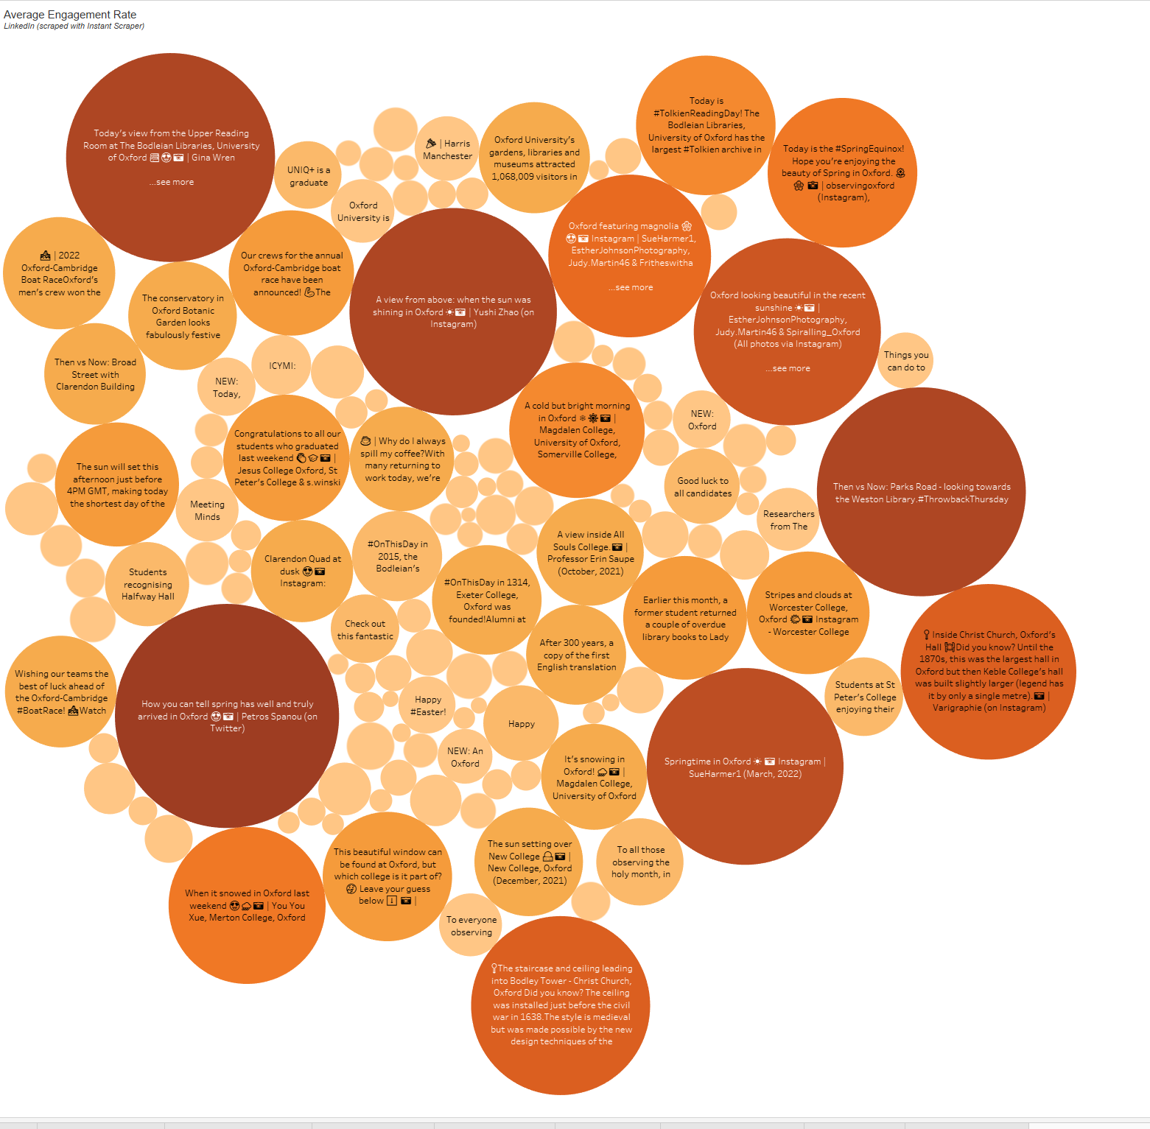

**Figure 5.12** LinkedIn posts and their average engagement rates

## 5.3 Discussions and Business Implications

The study set out to find out how and if Higher Education institutions were using social media for teaching and research activities and we can rightly regard social media as another platform for academic pursuit. The approach of reviewing all the major social media platforms helped reveal that this is research that is multi-faceted and requires a lot of resources and budget to effectively disposition all that is needed to complete it in its totality. But we have been able to unravel some salient issues.

# Conclusions with Project Limitations and Recommendations

With all that is written above, the conclusion would be that this is still a work in progress and would be in other to re-phrase the objectives of this study to be a justification to investigate the efficacy of social media as a tool for educational engagement. Existing literature already supports this (Larkins *et al.*, 2020) and it will be beneficial to research and develop a structured approach that is customised to each social media individually.

There will be a need to itemise and plan to overcome various challenges and limitations witnessed in this work which include but are not limited to:

* Limited proficiency in programming to allow the development of customised applications that can execute formulated plans. For example, a lot of time was spent trying to learn how to scrape an infinite scrolling website which used JavaScript to render the HTML.
* Closely related to the above is the proficiency required in the use of the Natural Language Processing tool and Machine Language as a whole.
* Getting reliable data is challenged by the various restrictions placed by the popular social media platforms which can be manoeuvred by having a budget to use available third-party applications like Octoparse, 80legs.com
* Not enough data points were Scraped due to the limited depth of knowledge to get things like impressions, geographical spread etc.
* Inability to get approval for a student/researcher account for Twitter API. This was applied for but did not get a final confirmation of approval or otherwise
* The research questions might just be deep enough for a full dissertation project.

To close, it is believed that with more time and material resources there is more that can be done to full answered that initial problem we set out to do but be that as it may we have been able to establish that social media is a platform for universities to engage all interested parties in line with their strategic objectives.

References

*5 of the Easiest Ways to Make Data an Integral Part of Your Business’ Digital Marketing* (no date). Available at: https://www.entrepreneur.com/article/379894 (Accessed: May 1, 2022).

*19 Social Media Metrics That Matter—And How to Track Them* (no date). Available at: https://blog.hootsuite.com/social-media-metrics/#Engagement_metrics (Accessed: May 1, 2022).

*Insights | Facebook Help Centre* (no date). Available at: https://www.facebook.com/help/794890670645072 (Accessed: April 30, 2022).

*Introduction | Python Web Scraping Cookbook* (no date). Available at: https://learning.oreilly.com/library/view/python-web-scraping/9781787285217/3b2ceb88-464f-4400-8e9e-6e1a29c07033.xhtml (Accessed: April 30, 2022).

Larkins, K. *et al.* (2020) “Use of social media for surgical education in Australia and New Zealand,” *ANZ Journal of Surgery*, 90(6), pp. 1004–1008. doi:10.1111/ANS.15768.

Li, F., Zhou, Y. and Cai, T. (2021) “Trails of Data: Three Cases for Collecting Web Information for Social Science Research,” *Social Science Computer Review*, 39(5), pp. 922–942. doi:10.1177/0894439319886019.

Macapinlac, T. (2018) “The Legality of Web Scraping: A Proposal,” *Federal Communications Law Journal*, 71. Available at: https://heinonline.org/HOL/Page?handle=hein.journals/fedcom71&id=431&div=24&collection=journals (Accessed: April 30, 2022).

*Robots.txt: Definition and How to Master it* (no date). Available at: https://makemebait.com/robots-txt-guide/ (Accessed: April 30, 2022).

del Rocío Bonilla, M. *et al.* (2019) “Insights into user engagement on social media. Case study of a higher education institution,” *https://doi-org.ezproxy.cardiffmet.ac.uk/10.1080/08841241.2019.1693475*, 30(1), pp. 145–160. doi:10.1080/08841241.2019.1693475.

Ssekiziyivu, B., Mukoki, J. and Musoke, E. (2021) “Adopting social media for learning among university students: a developing country perspective,” *https://doi-org.ezproxy.cardiffmet.ac.uk/10.1080/10494820.2021.1992638* [Preprint]. doi:10.1080/10494820.2021.1992638.

Tay, E. and Allen, M. (2011) “Designing social media into university learning: technology of collaboration or collaboration for technology,” *http://dx.doi.org.ezproxy.cardiffmet.ac.uk/10.1080/09523987.2011.607319*, 48(3), pp. 151–163. doi:10.1080/09523987.2011.607319.

*University of Oxford* (no date). Available at: https://www.ox.ac.uk/ (Accessed: May 1, 2022).

*University Rankings and League Tables 2022* (no date). Available at: https://www.thecompleteuniversityguide.co.uk/league-tables/rankings (Accessed: April 30, 2022).

William M. Bowen, Michael Schwartz, and Lisa Camp (2014) *End of Academic Freedom: The Coming Obliteration of the Core Purpose of the University*. Available at: https://ebookcentral.proquest.com/lib/cardiffmet/reader.action?docID=3315972 (Accessed: April 30, 2022).

Appendices

1. Assessment Plan_Sho Sowoolu st20219483

2. Video_Topic Review with Tutor_29032022

3. Transcript_Topic Review with Tutor_29032022

4. Tableau_Desktop_Social Media Data Visualisation_Sho Sowoolu_st20219493

5. Tableau _Prep_Social Media Data Cleaning Flow_Sho Sowoolu_st20219483

6. Robot.txt review for all social media platforms to scrape

7. SM Assignment Submission Plan

8. VBA code to clean Instagram_Instant Scraper

9. Youtube_Python Scrape Code. ipynb (Jupyter file)

10. Youtube_Python Scrape Code (PDF)

11. Scraped Social Media data_Cleaned (ZIP)

12. Scraped Social Media data_Raw (ZIP)

13. <https://public.tableau.com/app/profile/sho.sowoolu> (link to Tableau Public)